Website project plan

CS221 – October 27th 2014

James Elliott, Dan Hodgkins, Anand Gill (Overseer)

Contents

**DISCLAIMER**

**All parts of this plan were 50:50 created by JPE5 and DAH60**

**Introduction**

This is the project plan for the Website listed as RSPSview in the design specification. The main point of this document is to outline our ideas on what the website is preliminarily going to look like, any problems we foresee, the systems and protocols which we are intending to input into the website design and how the website interacts with users and admins. (describe what document is intended to achieve, outline objectives)

Within the document sections covered include initial design documents, use case diagrams for how the users, admins and android devices should interact with the website itself. It also contains the language choice of the website and how we intend the file structure is intended to be laid out. The person reading to document is supposed to be the project manager, the overseer and the group overseer. All information is self-contained and no external documents are necessary for viewing of this. (what it covers; or excludes; who should read the document; any other documents to be consulted)

Our document has specifically outlined that we have completed a set number of verifiable goals outlined below, also outlined is reasons why these goals have been achieved:

* Design
* Risk Anaylsis
* Gantt Chart
* Language choice
* Use case

(list specific objectives; goals and how they are attainted; should be verifiable)

**Overview (choice of platform [pc, mac, all most recent web browsers, tablets, mobiles] architecture, description of target users, notepad++)**

[Bootstrap: Handy CSS and JS stylesheets for ubiquitous mobile phone browsing as well as desktop. Good functionality with regards to older browsers, feature packed arguable one of the best style sheet templates on the internet. ]

[PHP: for maintaining and addition lookup and other such information to find user based stored details etc. And all communication with the server based off website side scripting.]

[Location production: accessed through GIS lookup one of the widest use location data storage ideas, with use of the google maps API to produce handy map. Uses database location lookup to emulate location feature. ]

[Login, server based commands: User login data will be stored server side along with device details so that all of their uploads can be verified/stored/accessed/deleted through their own account. Admins will also be able to access database records, credentials being stored server side also.]

**Use case(user case diagram for user, admin and other systems ie android)#**

|  |  |
| --- | --- |
| User | Server |
| **Add new**  **Delete own**  **Update/edit**  **Search by location alphabetical**  **Search by location date**  **Search by date**  **Search by user**  **Admin**  **Edit globally**  **Lock locations** | **Search by location**  **Search by name**  **Search by user**  **Order**  **Produce textual description**  **Produce list based on site**  **Store dates**  **Produce images**  **State abundance** |

**User interface design(drawing diagram explain what each thing does)**

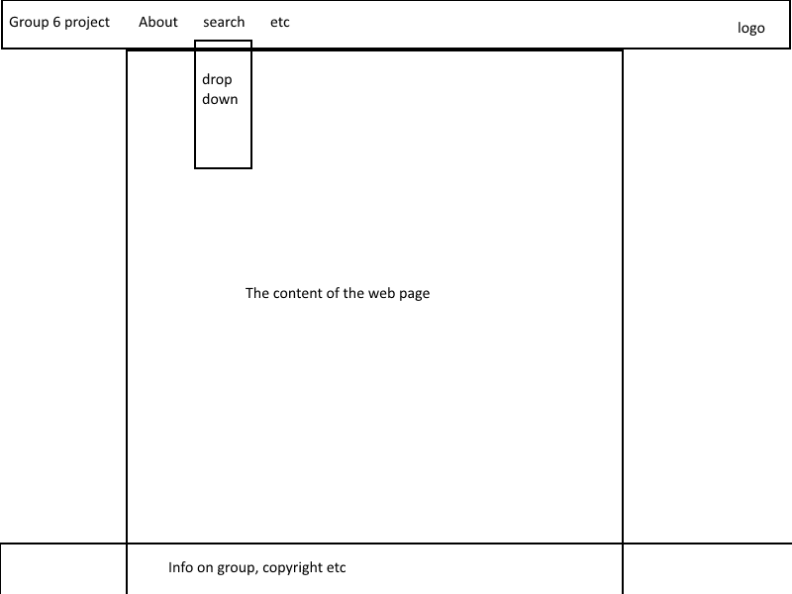 Dah60 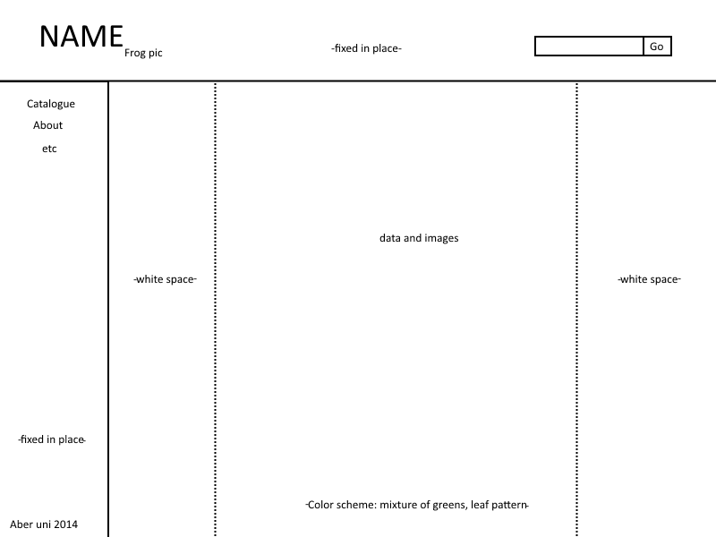JPE5 design

Designs slightly similar, top navbar being in both.

**Gantt chart(1 side of a4)**

plan, design, APIs and search lookups complete, prototype, server finished, testing functions, deadline

**Risk analysis( highlight any part of plan that will be problematic like slippage due to certain parts taking longer or illnesses)**

Server not being ready, API not working correctly, user authentication being impractical too hard to implement. Server Space being too small.